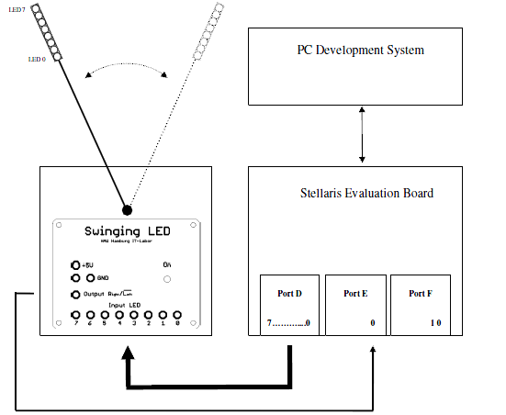

Setup:

We connected the swinging LED to the microcontroller as on the picture. First we connected ports D to the input of the swing LED. To the output of the swinging LED we connected port E. Afterwards, we gave a 5v power supply to the swinging LED.

Assignment 1.

We had to create a C-program which will make the swinging LED to display the left and the right margin. We did that based on a Nassi Schneiderman diagram, which is represented below:

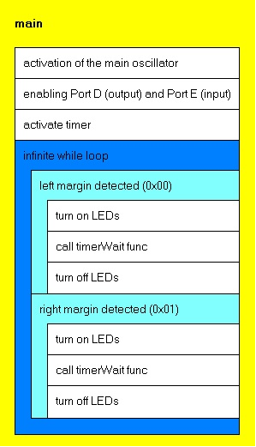

The actual C code is written below:

#define PART_LM3S9B92
#include "lm3s9b92.h"
#include "stdio.h"
// wait function
void wait(void){
int counter;
for(counter = 0; counter < 1000; counter++);
}
// main function
int main(void)
{
unsigned short gettime = 0;
// activate main oscillator at 16 MHz
SYSCTL_RCC_R = ((SYSCTL_RCC_R | 0x00000540) & ~0x000002B1);
gettime++; //waits for the stabilization of the oscillator
SYSCTL_RCGC2_R |= (1<<3); // clock activate for port D
SYSCTL_RCGC2_R |= (1<<4); // clock activate for port E
SYSCTL_RCGC1_R |= (1<<16); // activate timer 0
wait(); // we wait for the timer to activate

GPIO_PORTE_DEN_R = 0x01; // enable
GPIO_PORTE_DIR_R = 0x00; // input (for micro-controller)
GPIO_PORTD_DEN_R = 0xFF; // enable
GPIO_PORTD_DIR_R = 0xFF; // output(for micro-controller)
gettime++; //we wait for port D and E to activate

while (1)
{
while ((GPIO_PORTE_DATA_R&0x01) == 0x00) // detects left turning point
GPIO_PORTD_DATA_R=0xFF; //prints the left margin a column timerWait(1000);
GPIO_PORTD_DATA_R=0x00; //turns off the leds

while ((GPIO_PORTE_DATA_R&0x01) == 0x01); //detects right turning point
GPIO_PORTD_DATA_R=0xFF; //prints the right margin a column
timerWait(1000);
GPIO_PORTD_DATA_R=0x00; //turns off the leds

}
}

Assignment 2.
We created a C code which will display a short character stream. The diagram for it is displayed below:

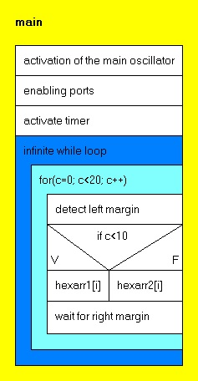

The C code is written below:

#define PART_LM3S9B92
#include "lm3s9b92.h"
#include "stdio.h"

// timerConfig function
void timerConfig(void)
{
// configure Timer 0
TIMER0_CTL_R &= ~0x0001; // disable Timer 0
TIMER0_CFG_R = 0x04;
TIMER0_TAMR_R = 0x02; // match disable, direction (down), periodic mode
TIMER0_TAPR_R = 2; // prescaler
}

// timerWait function
void timerWait(unsigned short usec)
{
TIMER0_TAILR_R= 8000000*(usec/1000);
TIMER0_CTL_R = 0x0001; // enable Timer 0
while((TIMER0_RIS_R & 0x01) == 0);
TIMER0_ICR_R |= 0x01;
TIMER0_CTL_R &= ~0x0001;

}

// wait function
void wait(void){
int counter;
for(counter = 0; counter < 1000; counter++);
}

// main function
int main(void)
{
unsigned short gettime=0;
int hexarr1[] = {0x00,0x00,0x00,0xFF,0xFF,0x8C,0x8A,0x71,
0x00,0x00,0x00,0x7E,0x81,0x81,0x7E,
0x00,0x00,0x00,0x7E,0x81,0x81,0x42,
0x00,0x00,0x00,0xFF,0x18,0x24,0xC3,
0x00,0x00,0x00,0xFF,0x91,0x91,0x91,
0x00,0x00,0x00,0x80,0x80,0xFF,0x80,0x80,0x00};

int hexarr2[] = {0x00,0x00,0x00,0x62,0x91,0x91,0x4E,
0x00,0x00,0x00,0x7E,0x81,0x81,0x42,
0x00,0x00,0x00,0xFF,
0x00,0x00,0x00,0xFF,0x91,0x91,
0x00,0x00,0x00,0xFF,0x70,0x0E,0xFF,
0x00,0x00,0x00,0x7E,0x81,0x81,0x42,
0x00,0x00,0x00, 0xFF, 0x91, 0x91,0x00};

// activate main oscillator at 16 MHz w/ external XTAL
SYSCTL_RCC_R = ((SYSCTL_RCC_R | 0x00000540) & ~0x000002B1);
gettime++;
SYSCTL_RCGC2_R |= (1<<3); // clock activate for port D
SYSCTL_RCGC2_R |= (1<<4);// clock activate for port E
SYSCTL_RCGC1_R |= (1<<16); //activate for Timer0
wait();

GPIO_PORTE_DEN_R = 0x01; // enable port 0
GPIO_PORTE_DIR_R = 0x00; // output

GPIO_PORTD_DEN_R = 0xFF; // enable ports from 0 to 7
GPIO_PORTD_DIR_R = 0xFF; // output

timerConfig();

while (1)
{
int i = 0, c = 0, p = GPIO_PORTE_DATA_R;

for(c = 0; c < 20; c++) // create a counter for the 2 arrays
{
while ((GPIO_PORTE_DATA_R&0x01) == 0x00)// detect left turning point
{
}
timerWait(10000);

if(c < 10) // 10 swing represent the first array
{
for(i = 0; i<45; i++)
{
GPIO_PORTD_DATA_R = hexarr1[i];
timerWait(1000);
}
}

else //other 10 swings represent the second array
{
for(i = 0; i<45; i++)
{
GPIO_PORTD_DATA_R = hexarr2[i];
timerWait(1000);
}
}

GPIO_PORTD_DATA_R = 0x00;
while ((GPIO_PORTE_DATA_R&0x01) == 0x01) //detects left turning point
{
}

}
}
}

Conclusion:
We managed to represent two short character streams on the swinging LED. In result of this, we can affirm that we learned how to work with the timer configuration and we succeeded in making it represent the two margins.

